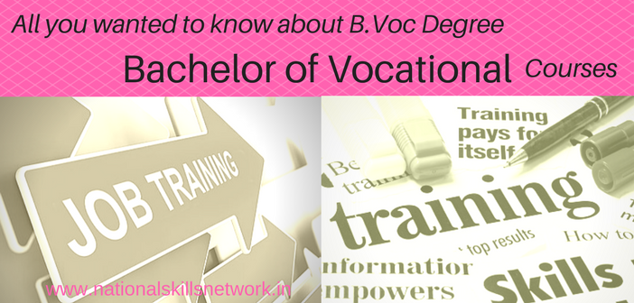

USP OF SHRI JJT UNIVERSITY
- 100% Job Guarantee
- Highly subsidized program
- Get career-oriented qualifications
- Needless to worry for joblessness
- Industrial Integration throughout the course

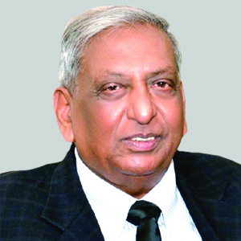

Dr. Vinod Tibrewala

I welcome you all to the family of Learners in Shri JagdishPrasad Jhabarmal Tibrewala University which was established in the year 2009 for the promotion of Education among all sections of society. This campus is emerging as a potential hub to impart education, training and entrepreneurship development skills to the youth, women & marginalized sections of society to generate new breed of human resources, who would be job creators & not job seekers.
It is my proud privilege to introduce B.VOC. courses in my university to enhance professional knowledge.
The University is not merely an examining body- It is primarily a
“NURSERY OF GOOD CITIZENS”

SHRI JAGDISHPRASAD JHABARMAL TIBREWALA UNIVERSITY
VIDYANAGRI, JHUNJHUNU-CHURU ROAD, P.O. CHURELA
JHUNJHUNU (RAJASTHAN), INDIA - 333001

SHRI JAGDISHPRASAD JHABARMAL
TIBREWALA UNIVERSITY
JHUNJHUNU, RAJASTHAN
BACHELOR OF VOCATION
(B.VOC.) PROGRAM

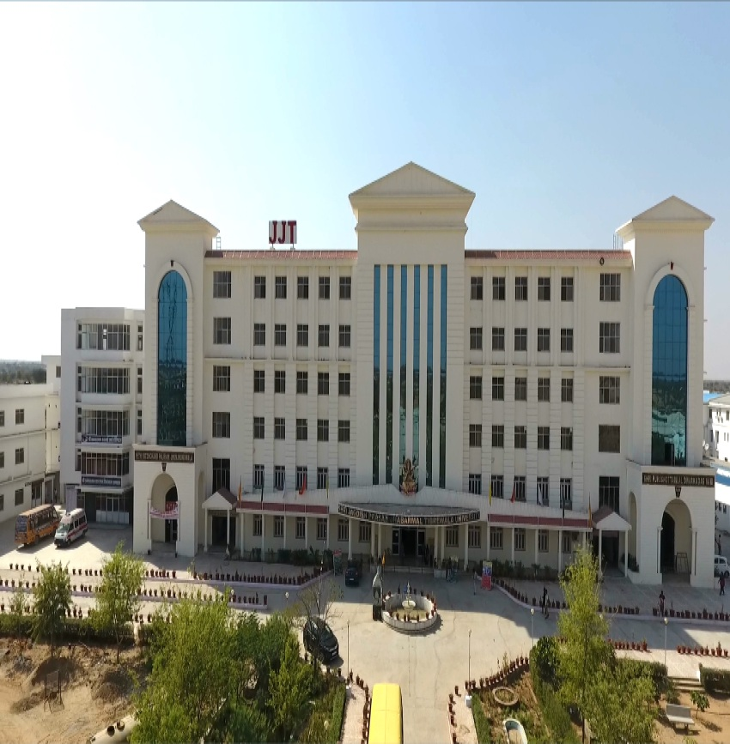
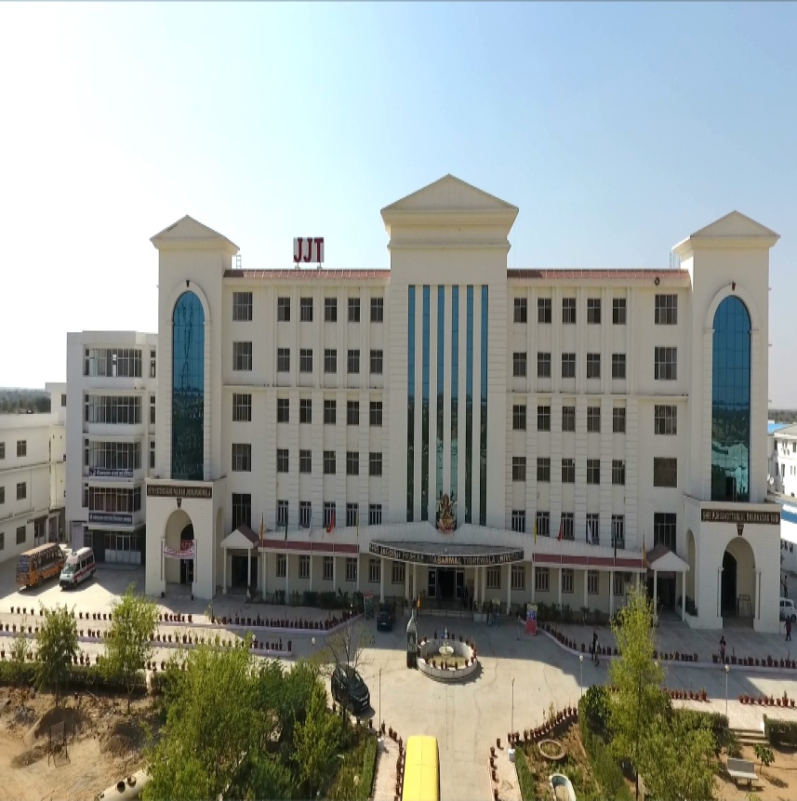

ADMISSION JANUARY 2019

ABOUT US:

We at JJTU, offer various Undergraduate, Post-Graduate & Research programs in the fields of Medical, Engineering, Pharmacy, Computer Applications, Nursing, Management, Legal Studies, Social Sciences, Basic & Life Sciences, Languages & Literatures, Agriculture, Forensics, Allied Health, & Criminology.

We provide wide range of career oriented courses for the working professionals, engineers, lawyers, science & arts graduates so that they can diversify their field & expand their scope.

Recently, we have launched Vocational Education inorder to impart knowledge and skills to our students, so that they could aspire & achieve vibrant success in their future.
भविष्य का सपना..
कौशल विकास अपना !!

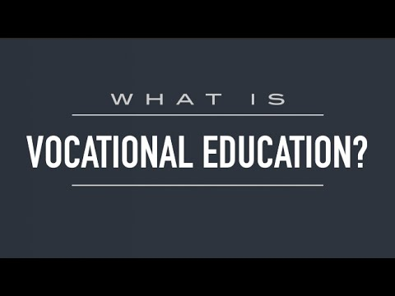

Vocational education is sometimes referred to as career education or technical education.

Vocational Training emphasizes skills and knowledge required for a particular job function.

BACHELOR OF VOCATION COURSE PROGRAMME
- B.VOC. Agriculture Skills
- B.VOC. Automotive Skills
- B.VOC. Carpenter Skills
- B.VOC. Construction Skills
- B.VOC. Electrical Skills
- B.VOC. IT/ Networking Skills
- B.VOC. Office Administration Skills
- B.VOC. Poly-Mechanic Skills
- B.VOC. Refrigeration & Air Conditioning

Skills
- B.VOC. Cyber Security & Incident

Response
- B.VOC. Forensic Document Examination
- B.VOC. Fingerprint Science
- B.VOC. Nutrition, Dietetics & Diabetic

Management
- B.VOC. Hospital Manager
- B.VOC. Gems & Jewellery Designing
- B.VOC. Instrumentation & Control
- Diploma Medical Nursing Assistant

SELECT YOUR CHOICE
- Certificate (6 months)
- Diploma (1 year)
- Advanced Diploma (2 years)
- B.VOC (3 years)
ELIGIBILITIY
- 10+2 in any Discipline

